BRIEF SITE UPDATE [Name of clinic) FAST-TRACK MODEL.
- Introduction
FAST-TRACK is a model which distributes ARVS to stable patients rapidly with abbreviated adherence counseling, from a designated FAST-TRACK room. FAST-TRACK participants receive a short symptom screening from a lay healthcare worker and a three-month drug supply from the Pharmacy Technologist. The objectives of the FAST-TRACK model of care are to reduce the workload of the existing health workers in facilities and to improve long-term retention in care by reducing access barriers.

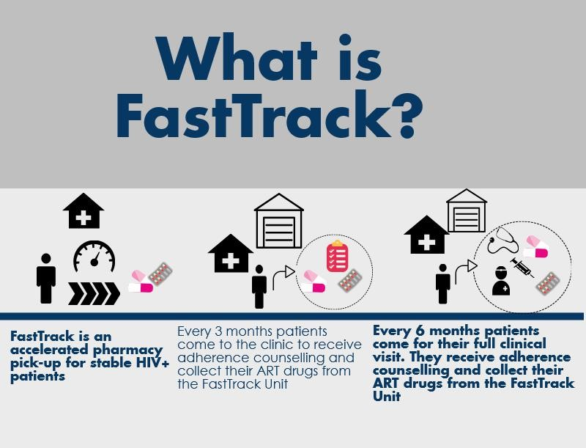

- Implementation experiences.
- Participant enrolments began on dd Month, 20yy and ended on dd Month, 20yy.
- Site was temporally closed on dd Month, 20yy because [give reason].
- The site was re-opened on dd Month, 20yy after [corrective action].
- Target enrollment was xx participants.
- A total of xx (Female-xx, Male-xx, Male adolescent-xx) participants were enrolled.
- Of the total enrolled, x have since left the study as [give reason and any action taken by the study/project for example to notify PI or in-charge].
- Challenges met and how they were addressed.
- Positive experiences and other appreciative remarks

- Next steps
- Exit activities to begin on dd Month, 20yy and to continue until dd Month, 20yy.
- Participants that have been on the study for 12 months from the date of enrolment will be exited from the study.
- At the exit visit we will:
  - Conduct a survey to assess patient satisfaction and patient centeredness for all participants.
  - Collect dry blood sample from each participant and sent to the [name of lab] for Viral Load testing.
- Phone and physical follow ups will be conducted on participants that do not come to the facility for exit procedures.
- The model will be transitioned to [specify]. Members from this team will be coming through to conduct sensitization for possible scale up.

